Experiment –5

Activity – 1

1.Create schema college

C:\Users\ASUS\Desktop\create schema.png

2. Create table-student and attributes are studid, studname, gender, subject, marks, grade.

3. Create table-Faculty and attributes are fac_id, fac_name, course, pass percentage.

4. Create table-department and attributes are dept-no, dept_name, section, no of students , pass percentage.

5. Create table-activity and attributes are act_id, act_name, no of students opted, category of activity.

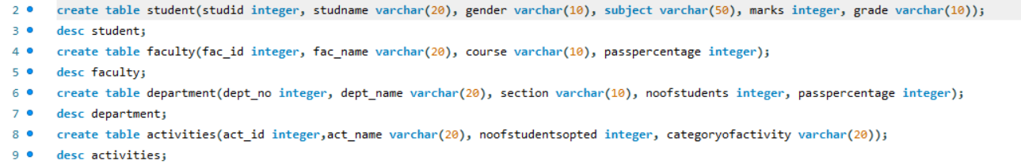

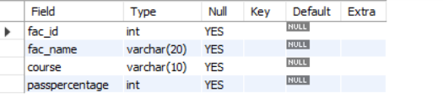

Student table:

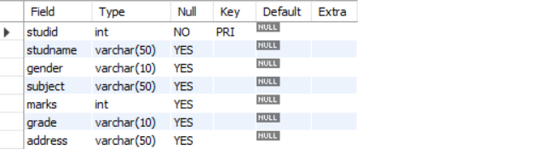

Activity – 2

1. Add address in student table, change the datatype size for student name and make studid as primary key

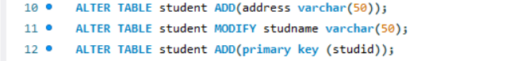

2. Add faculty total mentor details , make fac_id as primary key

C:\Users\ASUS\Desktop\fac.png

3.Add no of students in wise and make dept no as primary key

C:\Users\ASUS\Desktop\dep.png

4. Add faculty name and change the size of act_name and act_id as primary key

